Bismillahir rehman ir Raheem

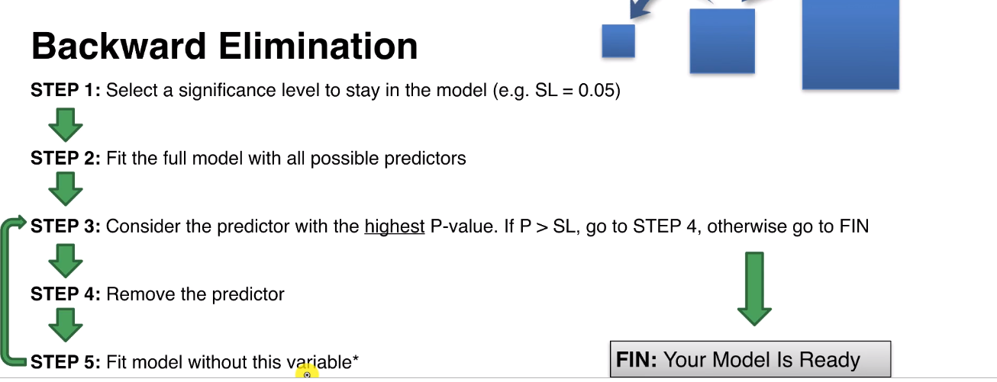

<https://www.udemy.com/machinelearning/learn/v4/t/lecture/5792106?start=0>

lect 52 53

|  |
| --- |
| 1. backwardElimination <- function(x, sl) { 2. numVars = length(x) 3. for (i in c(1:numVars)){ 4. regressor = lm(formula = Profit ~ ., data = x) 5. maxVar = max(coef(summary(regressor))[c(2:numVars), "Pr(>|t|)"]) 6. if (maxVar > sl){ 7. j = which(coef(summary(regressor))[c(2:numVars), "Pr(>|t|)"] == maxVar) 8. x = x[, -j] 9. } 10. numVars = numVars - 1 11. } 12. return(summary(regressor)) 13. } 15. SL = 0.05 16. dataset = dataset[, c(1,2,3,4,5)] 17. backwardElimination(training_set, SL) |